MD2201 Data Science
Course Project
S. NoDivBatch NoGroup NoRoll NoGr. NoName of Student1.D222512110693Prasad Ramnath Shelke2.3012110877Nikhil Sunil Shinde3.3112110326Pritam Bhausaheb Shinde4.3312110071Aditya Ramesh Shirsath5.3512111224Shravani Jayant BahulekarScience

Date of performance:

Project Title: Number of Bike Rented Predictor

Data Set Name: Seoul Bike Sharing Demand Data Set

Data set Link: https://www.kaggle.com/datasets/saurabhshahane/seoul-bike-sharing-demand-prediction

Data Set Description: Seoul Bike Sharing Demand Data Set is a multivariate dataset data set. It has 8760 instances and 14 attributes. The various attributes are –

Date: year-month-day
Rented Bike count - Count of bikes rented at each hour
Hour - Hours of the day
Temperature-Temperature in Celsius
Humidity - %
Windspeed - m/s
Visibility - 10m
Dew point temperature - Celsius
Solar radiation - MJ/m2
Rainfall - mm
Snowfall - cm
Seasons - Winter, Spring, Summer, Autumn
Holiday - Holiday/No holiday
Functional Day - NoFunc(Non Functional Hours), Fun(Functional hours)

Objective: The objective of the project is to predict the number of bikes rented on a given day based on weather conditions, time, day, etc.

Data Preprocessing (if any):

Converting categorical values to numeric values

Seasons: Summer, Autumn, Spring, and Winter are 4 categories.

Holiday: Holiday/ No Holiday are two categories.

Data normalization

Splitting data into train and test (80:20).

Total observations = 8465

Training = 6772

Testing =1693

Feature Selection (if any):

Based on P-value.

Using varImp()

Based on the correlation matrix.

Using Principal Component Analysis (PCA)

Algorithms Implemented: Explain algorithms with default argument values or set hyperparameters value.

Multiple Linear Regression – Multiple linear regression is used to predict the outcome of a response variable from multiple attributes. The arguments used are the y variable, x variables (Rented Bike count, Hour, Temperature, Humidity, Windspeed, Visibility, Dew point temperature, Solar radiation, Rainfall, Snowfall, Seasons and Holiday) and train data.

Random Forest - Random Forest Regression is a supervised learning algorithm that uses an ensemble learning method for regression. The ensemble learning method is a technique that combines predictions from multiple machine learning algorithms to make a more accurate prediction than a single model. The arguments used are the dependent variable, the dataset used for building the model, the number of trees to be grown in the random forest, TRUE importance to calculate the variable importance measures and the type of model which is regression.

Decision Tree – A decision tree builds regression in the form of a tree structure. The arguments used are dependent variable and independent variables, ANOVA method is used to minimize the sum of squared errors at each split and dataset used for building the model.

Support Vector Regression – SVR is a nonparametric technique that relies on kernel functions. The arguments used are dependent variable and train dataset. The kernel used for the training model is the Radial Basis Function kernel.

XGBoost - XGBoost is a scalable and efficient gradient-boosting algorithm that can be used for both classification and regression tasks. It combines the strengths of tree-based models with regularization techniques to improve performance and prevent overfitting. The arguments used are the dataset used for building the model, the maximum depth of each tree in the XGBoost model, the number of boosting rounds to perform during the training process and a watchlist that specifies the dataset used for monitoring the training process of the model.

CODE:

setwd("C:/Data science")

#libraries----

library(caTools)

library(randomForest)

library(caret)

library(e1071)

library(xgboost)

library(rpart)

#Read file----

f = read.csv("SeoulBikeData.csv")

f

summary(f)

dim(f)

any(is.na(f)) #finding null values in dataset

#Dropping non useful Columns based on IncMSE----

f<-f[!(f$Rented.Bike.Count==0), ]

drop<-c("Date","Functioning.Day","Snowfall","Wind.speed","Visibility","Holiday")

f1=f[,!(names(f) %in% drop)]

print(f1)

dim(f1)

summary(f1)

#Converting column input into numeric----

f2<-transform(f1,Seasons=as.numeric(as.factor(Seasons)))

print(f2)

dim(f2)

boxplot(f2,las=2)

#Normalization of Data----

n2<-function(b){(b-min(b))/(max(b)-min(b))}

fnor<-as.data.frame(lapply(f2[1:8], n2))

fnor

boxplot(fnor,las=2)

summary(fnor)

dim(fnor)

#Partition Data----

set.seed(1502)

sample_data <- sample.split(fnor, SplitRatio = 0.8)

train_data <- subset(fnor, sample_data == TRUE)

test_data <- subset(fnor, sample_data == FALSE)

#mlr----

ml1.mlr<-lm(Rented.Bike.Count ~ Hour + Temperature + Humidity+ Dew.point.temperature + Solar.Radiation + Rainfall + Seasons ,data=train_data)

s1<-summary(ml1.mlr)$coef

print(s1)

summary(ml1.mlr)

#predictions1 <- ml1.mlr %>% predict(test_data)

predictions1 <- predict(ml1.mlr, test_data)

rmse.1 <- RMSE(test_data$Rented.Bike.Count, predictions1)

r2.1 <- R2(test_data$Rented.Bike.Count, predictions1)

mae.1 <- MAE(test_data$Rented.Bike.Count, predictions1)

cat("\n\nMetric count for MLR is :\nRMSE = ",rmse.1)

cat("\nR Square = ",r2.1)

cat("\nMAE = ",mae.1)

#Random Forest----

set.seed(1234)

ml2.rf <- randomForest(Rented.Bike.Count ~ ., data = train_data, ntree = 500, importance = TRUE, type = "regression")

ml2.rf

s2<-summary(ml2.rf)

print(s2)

plot(ml2.rf)

predictions2 <- predict(ml2.rf, test_data)

rmse.2 <- RMSE(test_data$Rented.Bike.Count, predictions2)

cat("\n\nMetric count for RF is :\nRMSE = ",rmse.2)

r2.2 <- R2(test_data$Rented.Bike.Count,predictions2)

cat("\nR Square = ",r2.2)

mae.2 <- MAE(test_data$Rented.Bike.Count, predictions2)

cat("\nMAE = ",mae.2)

#Supprt Vector Machine----

ml3.svm = svm(Rented.Bike.Count ~., data=train_data)

print(ml3.svm)

predictions3 <- predict(ml3.svm, test_data)

rmse.3 <- RMSE(test_data$Rented.Bike.Count, predictions3)

cat("\n\nMetric count for SVM is :\nRMSE = ",rmse.3)

r2.3 <- R2(test_data$Rented.Bike.Count,predictions3)

cat("\nR Square = ",r2.3)

mae.3 <- MAE(test_data$Rented.Bike.Count,predictions3)

cat("\nMAE = ",mae.3)

#Xgboost----

set.seed(1231)

train_x = data.matrix(train_data[,-1])

train_y = train_data[,1]

test_x = data.matrix(test_data[,-1])

test_y = test_data[,1]

xgb_train = xgb.DMatrix(data = train_x, label = train_y)

xgb_test = xgb.DMatrix(data = test_x, label = test_y)

watchlist = list(train=xgb_train, test=xgb_test)

ml4.xgb <- xgb.train(data = xgb_train, max.depth = 3, watchlist=watchlist, nrounds = 74)

predictions4 <- predict(ml4.xgb, xgb_test)

rmse.4 <- RMSE(test_y, predictions4)

cat("\n\nMetric count for XgBoost is :\nRMSE = ",rmse.4)

r2.4 <- R2(test_y,predictions4)

cat("\nR Square = ",r2.4)

mae.4 <- MAE(test_y,predictions4)

cat("\nMAE = ",mae.4)

#Decision Tree----

ml5.dt <- rpart(Rented.Bike.Count ~ Hour + Temperature + Humidity+ Dew.point.temperature + Solar.Radiation + Rainfall + Seasons, method = "anova", data = train_data )

print(ml5.dt)

plot(ml5.dt, uniform = TRUE,main = "Decision Tree using Regression")

text(ml5.dt, use.n = TRUE, cex = .6)

predictions5 <- predict(ml5.dt, test_data)

rmse.5 <- RMSE(test_data$Rented.Bike.Count, predictions5)

cat("\n\nMetric count for DT is :\nRMSE = ",rmse.5)

r2.5 <- R2(test_data$Rented.Bike.Count,predictions5)

cat("\nR Square = ",r2.5)

mae.5 <- MAE(test_data$Rented.Bike.Count,predictions5)

cat("\nMAE = ",mae.5)

Evaluation Parameters used:

R square

Root Mean Squared Error (RMSE)

Mean Absolute Error (MAE)

Results: Quantitative findings and Plots.

Based on P-value.

Removed Visibility and Wind speed
 | R2 | RMSE | MAE
MLR | 0.5398373 | 0.1233447 | 0.09292138
Random Forest | 0.8694684 | 0.06586419 | 0.04214869
Decision Tree | 0.6907592 | 0.1011512 | 0.07288018
Support Vector Regression | 0.7757286 | 0.08731926 | 0.05376273
xgboost | 0.8648636 | 0.06688322 | 0.04450271

Using varImp()

varImp plot on random forest algorithm showing the importance of each variable. Snowfall and Holiday have the least significance and Hour is the highest.

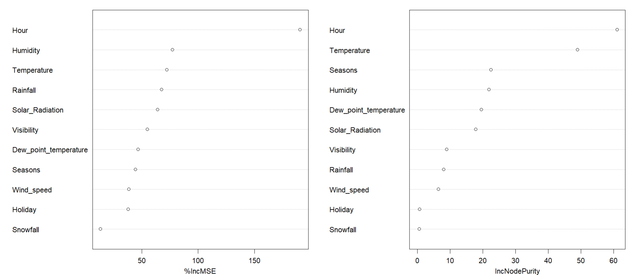

Removed Snowfall, Holiday, Rainfall, Wind Speed
 | R2 | RMSE | MAE
MLR | 0.6281587 | 0.1109072 | 0.08858721
Random Forest | 0.8808706 | 0.06310622 | 0.04386928
Decision Tree | 0.6976142 | 0.09593143 | 0.07322589
Support Vector Regression | 0.8598966 | 0.06353324 | 0.04423193
xgboost | 0.860088 | 0.06403106 | 0.04491506

Based on the correlation matrix.

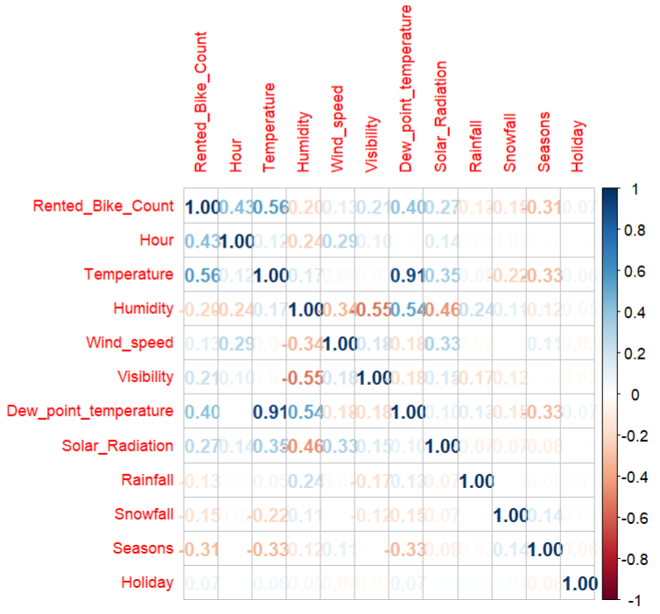

Correlation matrix which showed a correlation in various variables. Dew point temperature and Temperature showed maximum correlation (approx up to 0.91).

Removed Dew point temperature
 | R2 | RMSE | MAE
MLR | 0.5370758 | 0.1213251 | 0.09062209
Random Forest | 0.8624813 | 0.06635607 | 0.04261616
Decision Tree | 0.6575196 | 0.1043817 | 0.07430606
Support Vector Regression | 0.7542247 | 0.08887181 | 0.05605392
xgboost | 0.8546704 | 0.0679566 | 0.04554153

Using Principal Component Analysis (PCA)

Removed Rainfall, Holiday
 | R2 | RMSE | MAE
MLR | 0.525037 | 0.1253098 | 0.09430913
Random Forest | 0.8632942 | 0.06756251 | 0.04333183
Decision Tree | 0.6907592 | 0.1011512 | 0.07288018
Support Vector Regression | 0.76581 | 0.08902849 | 0.05473097
xgboost | 0.8522732 | 0.06995845 | 0.04634666

The results obtained after training the model using various algorithm and based on various feature selection method is as follows:

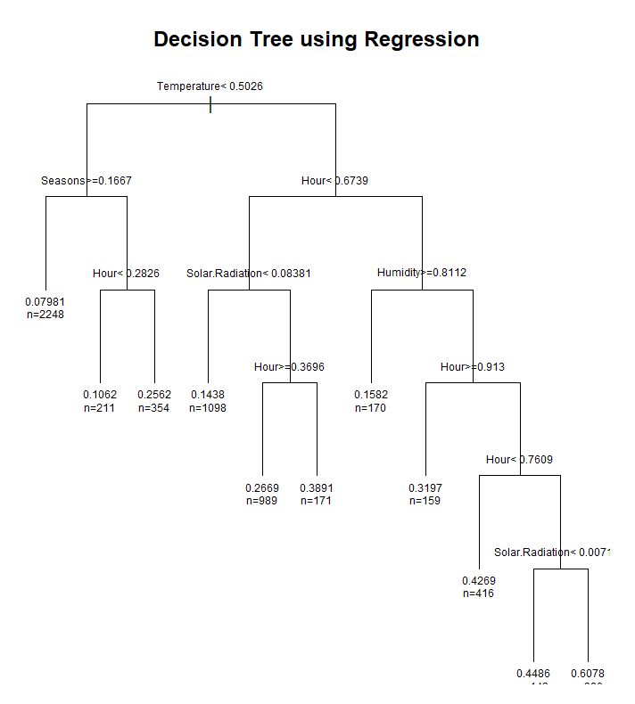

Decision Tree with R square = 0.69, RMSE = 0.09, MAE = 0.0732.

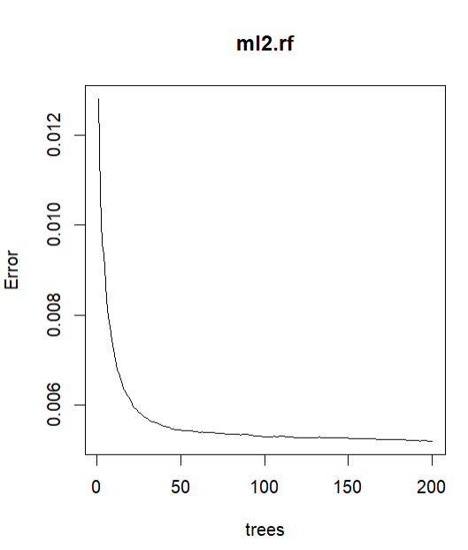

Random Forest graph depicting reduced error as the number of trees increases(max = 200).

Comparison

R2

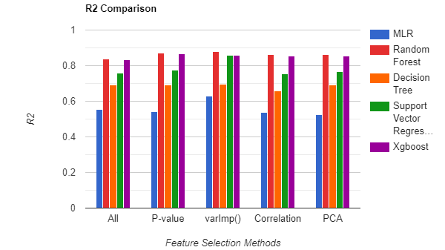

Comparison of R square values of various algorithms based on the method of feature selection. The best-performing models from highest to lowest are random forest, XGBoost, SVM, Decision Tree, and MLR.

RMSE

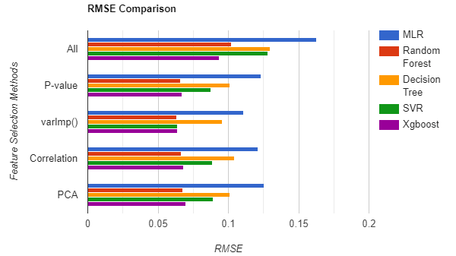

Comparison of RMSE values of various algorithms based on the various methods of feature selection. The Random Forest has a minimum RMSE value almost in all cases.

MAE

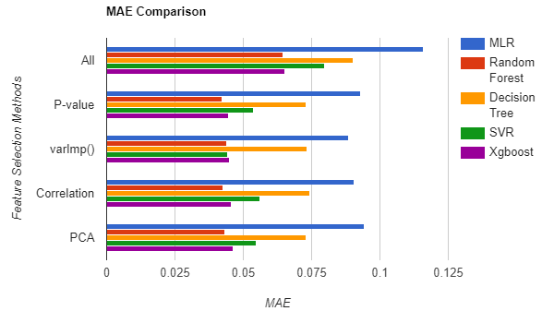

Comparison of MAE values of various algorithms based on the method of feature selection. The Random Forest has a minimum MAE value in all cases.

Actual vs Predicted Graph

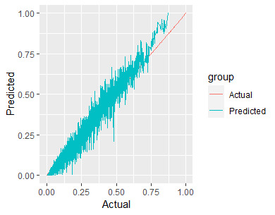

Conclusions:
- Here we can see in the 18th hour of the day traffic for rental bike count is more. And in every season traffic of rental bike count is more in the 17-19th hour of the day and in the morning at 8 pm.
- Bike is rented when functioning day is there otherwise not.
- Most numbers of Bikes were rented in summer, followed by autumn, spring, and winter. May-July is the peak Bike renting Season, and Dec-Feb is the least preferred month for bike renting.

‘Hour’ of the day holds the most important among all the features for prediction.

The models performed better with outliers rather than removing them.

Temperature and Dew point temperature has a maximum correlation. Hence, removing either gave a higher R square value.

Out of five models used, Random Forest performed best in terms of R-square value (0.8808706) followed by XGBoost (0.8648636), SVM (0.8598966), and Decision tree (0.6976142).

Random Forest performed best/lowest in terms of Root Mean Square Error (RMSE) value (0.0.06310622) followed by SVM (0.06353324), XGBoost (0.06403106), and Decision tree (0.09593143).

The R-square value increased after training the model by using features from the varImp() function. This included removing Snowfall, Holiday, Rainfall, Wind Speed, Functional day, and Date.

Random Forest gave better results when the number of trees was set to 1000 instead of 200.

